**Badminton**

**Rules**

* A match consists of the best of 3 games to 21 points
* Every time there is a serve –a point is scored

**Singles**

* At the beginning of the game (0-0 evens) the server serves from the right side of the court. When the servers score is odd, the server serves from the left service court.
* If the server wins a rally, the server scores a point and then serves again from the alternating service court.
* If the receiver wins a rally, the receiver scores a point and becomes the new server. They serve from the appropriate service court,

**Doubles**

* A side has only one ‘service’
* The server will always begin serving on the right side.
* You continue with the same server until you lose the rally.
* When the first pair loses their serve, it is then hand out to the opposing pair. (If the score is even it will be from the right if the score is odd they serve from the left)
* When the second pair loses the rally it is hand out to the pair who served first, but the second person who has not yet served will serve.
* When that rally is over it is hand out to the second pairing and to the person who has not yet served.
* Each person takes it in turn to serve.
* When the server wins a point your partner will keep changing sides until they lose the rally , you stay in those positions until you next serve and win the point

**Relevant Components of Fitness**

**Physical Components –**

**Aerobic Endurance** – For maintaining fitness levels throughout the whole game

**Speed** – For movement around the court

**Skill Components -**

**Agility –** For changing direction at speed, depending on where the shuttlecock is hit

**Reaction time –** to respond quickly to where the shuttlecock has been hit

**Power** – For hitting the shuttle to the back of the court

**Co-ordination** – To enhance the ability to hit the shuttlecock with accuracy

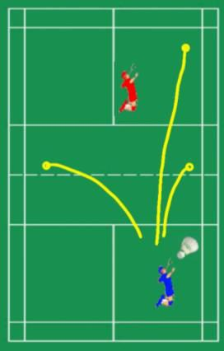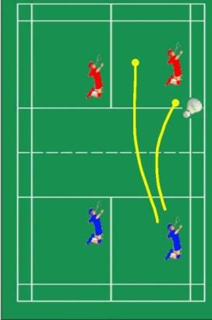

**Tactics**

* When playing aiming the shuttlecock at the players weaker side will increase the chance of them making a mistake
* Push the shuttle to the back of the court to giving the opposition fewer choices of shots when the return the shuttlecock
* Alternate your shots front drop shot or overhead clear to the back of the court
* Play shots alternate sides

**Set play**

* In pairs play either front and back (one person plays all net shots the back person will play long court shots
* In pairs play side by side, each player is responsible for their own ½ of both front and back of court

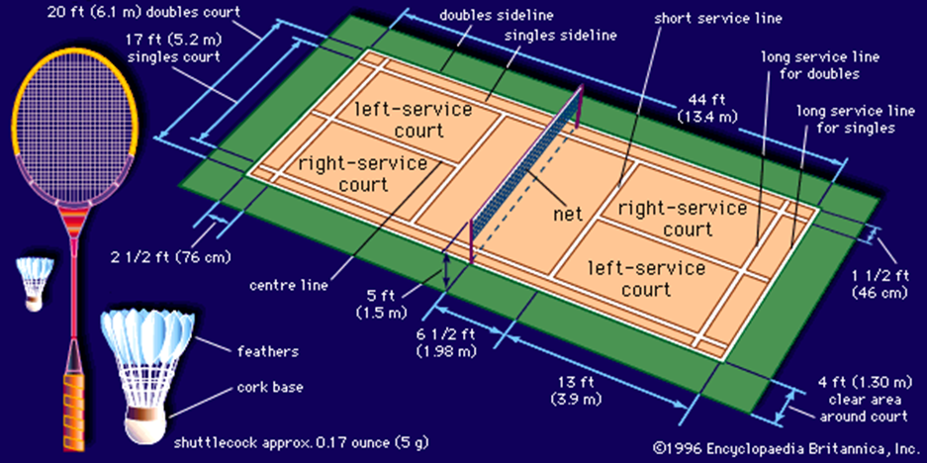

**Equipment**

Badminton Racket

Shuttlecock (plastic – Feather)

Trainers

Net – 2.5 feet tall and 20 feet wide

Weighted posts – 5 feet tall-

**Safety**

**PE Kit –** including the correct footwear to reduce chance of injury

**No jewellery**

**Weighted posts** – To make sure that the tension of the net remains taut and does not pull the posts over

**Governing Body**

**Playing Area**

**Basic Skills**

Service – short, high, flick or drive

Shots – forehand, backhand, overhead clear, drop shot or smash.

Lift

Advance – block shot, drop, straight or angled

Round-the-head-clear from weaker hand