[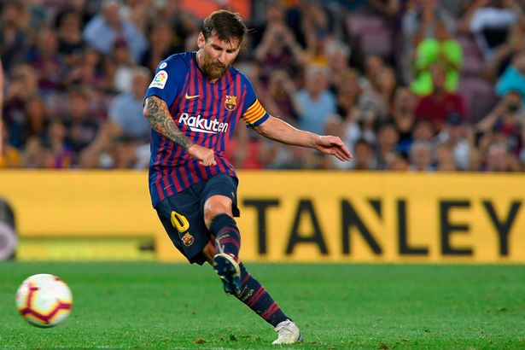](https://www.google.com/url?sa=i&rct=j&q=&esrc=s&source=images&cd=&cad=rja&uact=8&ved=2ahUKEwjoq7Hur7PdAhUIJ8AKHSsnDwIQjRx6BAgBEAU&url=https://www.mirror.co.uk/sport/football/transfer-news/lionel-messi-scored-12-goals-13207020&psig=AOvVaw2rcrFJnzWySL9_OW5aOQeA&ust=1536769820113807)

**Relevant Components of Fitness**

**Physical Components**

**Aerobic Endurance** – To perform at maximum performance levels and can continue to run and work hard for a full game.

**Power** – To leap up to win a header or to hold off a defender whilst dribbling.

**Speed** – To beat opponents to the ball or to move quickly into space/get away from an opponent.

**Skill Components**

**Agility** – To be able to dribble and/or change direction without losing speed, balance or possession of the ball.

**Balance** – Dynamic balance when timing tackles, dribbling with the ball or shooting to allow control and stability.

**Coordination** – To coordinate jockeying and timing of the tackle or dribbling and protecting the ball.

**Tactics & Set plays**

**Formations** – 4-4-2, 3-5-2, 4-3-3, 4-5-1

These are just a few of a number of different formations that can be used.

**Direct** – Get the ball forwards quickly with long balls.

**Counter Attack** – Hit teams on the break when possession is turned over.

**Possession** – Keeping hold of the ball and waiting for mistakes from the other team’s defence.

**Equipment / Health & Safety**

**Shin Pads** – must be worn at all times

**Jewellery** – No Jewellery worn

**Team Jerseys** – must be worn to differentiate team and players

**Footwear** – Football boots must be worn

**Rules**

**Freekick** – Direct you can shoot straight at goal. Indirect you have to pass before shooting.

**Penalty Kick** – If a foul is committed in the box a penalty from 12 yards is taken.

**Advantage** – The referee will play advantage if a foul is committed but the team still have possession of the ball.

**Offside** – If there are not 2 defenders (1 can be the goalkeeper) between the attacker who receives the ball and the goal.

**Playing Area**

[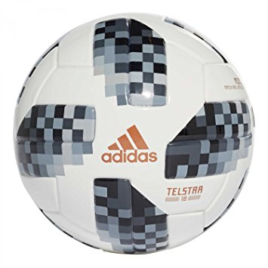](https://www.google.com/url?sa=i&rct=j&q=&esrc=s&source=images&cd=&cad=rja&uact=8&ved=2ahUKEwje96LurbPdAhUpBMAKHYxgBIUQjRx6BAgBEAU&url=https://www.amazon.co.uk/adidas-Official-World-Telstar-Football/dp/B078VFWXNW&psig=AOvVaw3Xe8K3wq-QDwl-ET8LYR9q&ust=1536769276904670)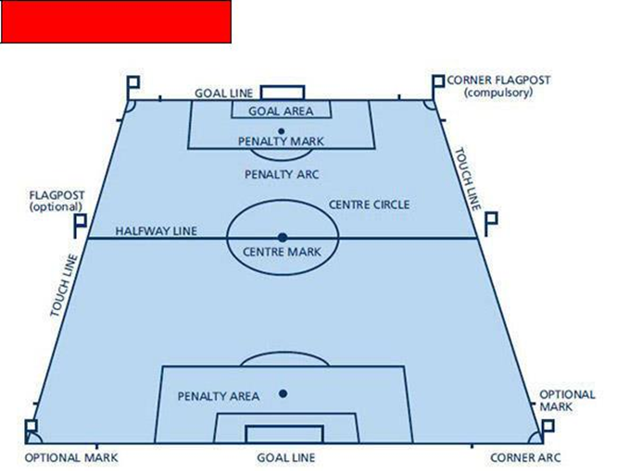

**Governing Body**

The Football Association 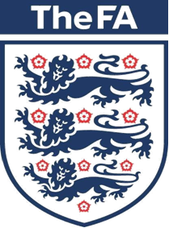

**Positions**

|  |
| --- |
| GK: Goalkeeper  RB: Right Back  LB: Left Back  CB: Centre Back  RM: Right Midfield  LM: Left Midfield  CM: Centre Midfield  ST: Striker |
|  | |

**Basic Skills**

1. Receiving skills 2) Turning skills 3) Finishing skills

4) Travelling with the ball 5) Passing over varying distances

6) Attacking and defending skills