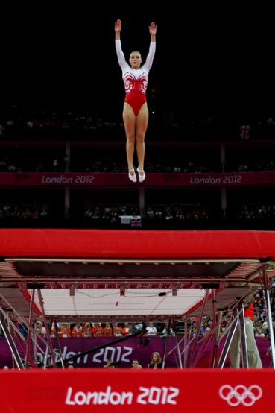

**Relevant Components of Fitness**

**Balance** – needed to remain on the cross when performing skills

**Coordination** – needed when performing all the required skills under control

**Endurance-** needed to complete a routine whilst performing each of the skills to a high level

**Power-** needed on take-off to gain height

**Flexibility –** needed to get limbs into a specific position for each of the required skills

**Tactics & Set plays**

**Height -**All skills must be performed at the same height during the routine, otherwise points will be deduced.

**Travel-** All skills must be performed on the centre of the cross otherwise points will be deducted

**Form** – All skills have to be performed with straight limbs and excellent body tension. Limbs also have to be in specific positions and each shape has to be clearly seen during each of the skills. Points will be deducted for poor performance

**Skills** –Skills are worth different points depending on their difficulty. During the voluntary routine choose a set of skills you can perform well, to give you the highest amount of points possible. (Normally a 10 bounce routine) Set routines must be performed as they appear on the cards, otherwise points are deducted.

**Rules**

* Socks and tight clothing must be worn whilst performing
* Spotters must be present and watching performers
* Performers must face forward and bounce on the cross in the centre of the bed

**Equipment / Health & Safety**

**Mats** – must be placed around the outside of the trampoline

**Padding** – must be around the outside of the main bed

**End Decks** – must be placed at the ends of each trampoline

**Spotter**s- must be present around each sides of the bed and watching the performer

**Clothing** – No zips, socks must be worn, hair tied back no jewellery

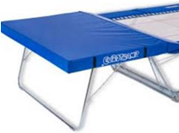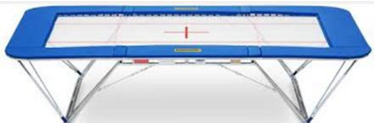

**Advance Skills**

**Seat drop ½ twist to stand**

**½ twist to seat**

**Seat drop ½ twist to seat drop (swivel hips)**

**Front drop**

**Front drop ½ twist to feet**

**½ twist to front drop**

**Front drop ½ turn to front drop (½ turn table) 180**

**Front drop full turn to front drop (full turntable) 360**

**Back drop**

**Back drop ½ twist to feet**

**½ twist to back drop**

**Back drop to back drop (cradle)**

**Front drop to back drop**

**Back drop to front drop**

**Front somersault**

**Back somersault**

**Barani (no handed cartwheel in the air)**

**(10 bounce routine to include front or back somersault)**

**Basic Skills**

* Straight bouncing without traveling
* Controlled coordinated arm movement
* Tuck jump
* Pike jump
* Straddle jump
* ½ twist jump
* Full twist jump
* Seat drop

**Governing Body g Body**

**Playing Area**