KEY

Materials

Acrylic

Plywood

MDF

PCB

Solder

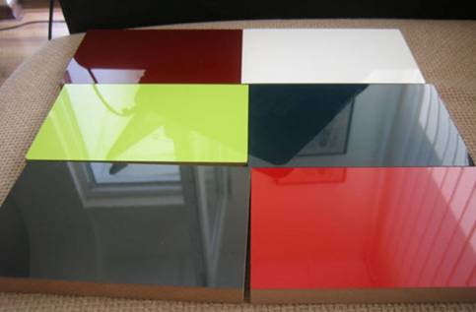

ASSESSMENT

Assessment Task 1: I will be assessed on my understanding of box joints

Assessment Task 2: I will be assessed on different levels of production where I should be able to pair products with the method used to manufacture them.

Assessment Task 2: I will be assessed on the four most commonly used methods of manufacturing out of plastic.

WHAT WILL I BE LEARNING ABOUT THIS TERM?

Designing and the use of CAD/CAM in modelling and prototyping. I will also learning about common materials used in small-scale projects.

KEY SKILLS

* Analysis
* Research
* Modelling and prototyping
* Problem solving

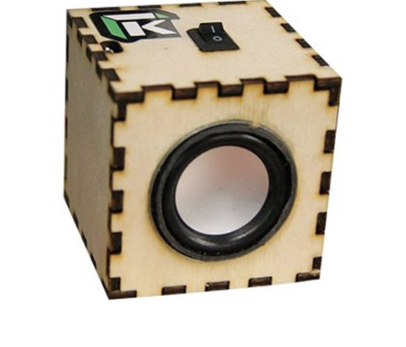

BRIEF SUMMARY OF UNIT

I will be studying the skills I need to be successful in D&T through CAD/CAM, modelling and prototyping. I will also learn about soldering and some of the key components used in electronic circuits and their function.

KEY DEFINITIONS

* Softwood - Softwood is the wood from trees such as pines, which grow quickly and can be cut easily.
* Hardwood–Hardwood is wood such as oak, teak, and mahogany, which is very strong and hard. Tends to be deciduous and slow growing.
* CAD/CAM– Computer aided design/computer aided manufacture.

