**Relevant Components of Fitness**

**Physical components –**

**Cardiovascular fitness**- this is in 5000m or 10000m because you are exercising the whole body for a long period of time.

**Flexibility-** this is used when jumping over hurdles. So you can stretch and get over the hurdles without pulling your hamstring.

**Body composition**- This is important because a long distance runner would be quite slim and small, so they don’t carry a lot of weigh. But, a sprinter would be more muscular because they have that explosive power form their muscles.

**Skill components –**

**Reaction time**- when starting a 100m sprints because a second delay could cause lead to loss.

**Speed**- running a sprint you are going to need to be quick.

**Balance-** when taking part in any event, you are going to need balance so you don’t fall over.

**Tactics & Set plays**

* When running like you will most probably see the leader in second or third place because there is less wind resistance there.
* In a long distance events you also may see some athletes with a pace maker. What they do, it’s a person that runs quickly at the start.

**Rules**

There are many different rules in athletics.

* Don’t step out your lane in the short distance or relay.
* Don’t step over the line when jumping.
* Always exit the key at the back not the front. This is in discus and hammer throws.
* Make sure your javelin doesn’t tale.

**Equipment / Health & Safety**

* Some athletics equipment you have to be very safe with like a javelin, it’s sharp and pointy. To keep everyone safe, everyone is behind or far away from the throwing zone.
* This is the same with hammer throw and discus.
* Running spikes, they can be very sharp and pointy so be careful you don’t get to close to the person’s feet when running because they could catch you and cut you.

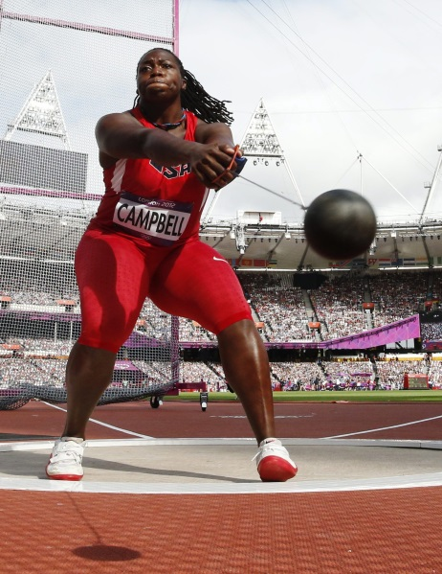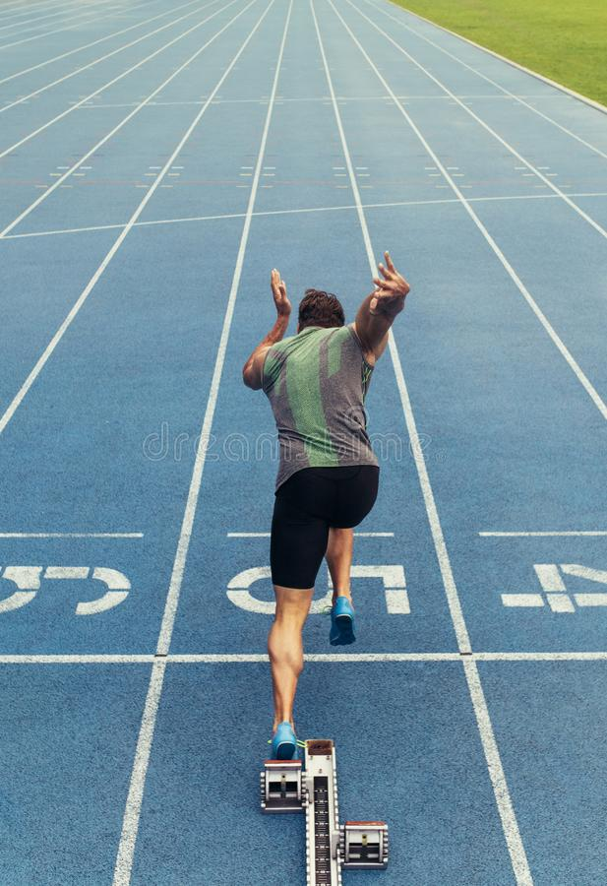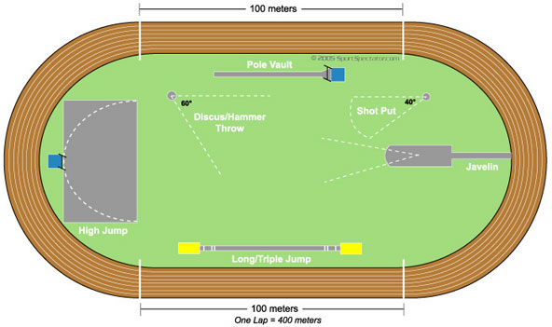

**Governing Body**

**Basic Skills**

* Throwing- javelin, hammer throw, shot put, discus
* Jumping- triple, long, high
* Running, 800m-10000m.
* Sprinting- 100m-400m

**Playing Area**