**Equipment / Health & Safety**

Handballs – A leather/synthetic material ball measuring 50-60cm in circumference.

Health and safety – A clear playing surface with no obstructions. Court boundaries must be away from walls/fences etc.

Contact between players must be controlled and not include pushing, striking or pulling opponents.

**Rules**

Handball teams consist of 14 players, with 7 on court at any one time.

Handball matches are played over two halves of 30 minutes, with overtime and penalties to decide winners if tied.

Players must move the ball quickly, holding it for no more than 3 seconds without dribbling, passing or shooting.

Players must bounce the ball every 3 steps, and must not enter the goalkeepers’ areas at any stage.

**Tactics & Set plays**Handball is a fast-paced, attacking invasion game. The idea of handball is to move the ball forward quickly. Negative play is punished by giving possession to the opposing team.  
Free throws may be awarded for fouls committed outside the goal area, or where there is no opportunity to score.  
For fouls committed in or near the goal area, a penalty may be awarded which is taken from 7 metres away.

When defending, teams usually form a line in front of the goal area and attempt to block/frustrate their opponents.

**Relevant Components of Fitness**

Physical –

**Endurance** – Handball is a fast-paced, high energy game so good endurance is required to maintain performance throughout the 30 minute halves.  
**Flexibility** – Handball players require flexibility on court to be able to generate passing opportunities, shoot from awkward positions or make vital blocks and interceptions. 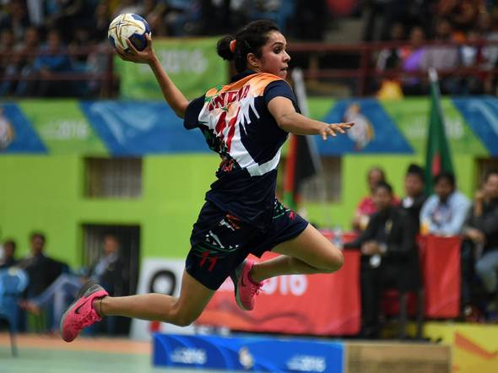  
**Power -**  Power is crucial in handball to be able to fire shots past a goalkeeper from a distance.  
Skill –

**Coordination** – Hand-eye co-ordinationis required to accurately pass, catch and shoot with the ball, whilst also being used to dribble at speed.  
 **Agility** – Handball players must be agile to quickly move and evade their opponents. Goalkeepers must be agile to react to shots on goal and awkward bounces.  
**Reaction time** - In particular, goalkeepers will need to react quickly to shots on goal as the ball can be thrown downwards and bounce up. Quick reactions will benefit defenders trying to intercept passes.

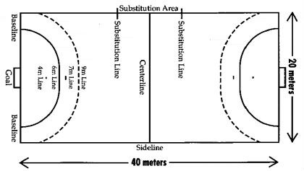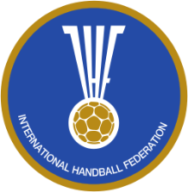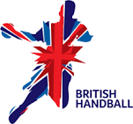

**Basic Skills  
Passing –** Overarm passing may be used to pass the ball above an opponent, to the chest area of your teammate. Alternatively, a bounce pass could be used to bounce the ball past the opponent.

**Shooting –** Shooting must occur from outside the Goal area, although players may land in the area after a jump shot.

**Dribbling –** Players must bounce the ball every 3 steps when moving with the ball. Double dribble, as with basketball, is when a player stops, holds the ball, then continues to dribble again.

**Governing Body**

The **International Handball**  **Federation** oversees Handball around the world, while **British Handball** oversees Handball in Britain.

**Playing Area**A court measuring 40 metres, by 20 metres with a semi-circle and a goal at either end. The goals measure 3 metres by 2 metres at either end.